PLAY:

A PILE OF LEAVES

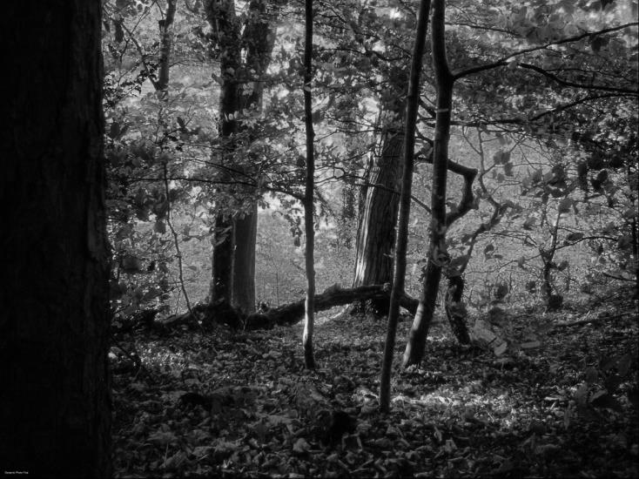

Pamela Erices
Felipe Navarrete
María José Verdugo

C.C. Initial II

Setting

It is around midnight and the darkness which covers the trees makes them look as if someone is hiding into the shadows. The leafy trees make almost impossible for the moonlight to break through the leafage and light the pathway.
The distant whispers caused by the animals which maraud in the woods disturb the quietness of whoever’s mind.
In the middle of this darkness, there is a campfire that lights a small area of the woods and which main goal is to provide some light to the campers sitting next to their tent.

Characters descriptions

Peter: He is a twenty-one-year-old teenager. He has short brown hair and green eyes. He goes to college and plays on the football team; hence; he has a fit body due to he trains four times a week. Peter is Giselle’s brother. He is responsible, trustworthy and doesn’t like partying too much, but still he likes spending some quality time with his best friends Jake and Jennifer.

Jake: He is a twenty-one-year-old teenager and he is Peter’s best friend. He is the team’s quarterback. He’s got short blonde hair and brown eyes. He likes partying with his friends, dating girls and works at a coffee shop with his best friend Jennifer.

Jennifer: She is a twenty-one-year-old teenager who has long curly blonde hair and green eyes. She is tall, thin and she is part of the cheerleader. She is Jake and Peter’s best friend and like spending time with them between classes. She works with Jake at a cafeteria.

Giselle: She is an eighteen-year-old teenager and Peter’s sister. She’s got shoulder length straight brown hair and green eyes like her brother. She has just finished high school and, unlike her brother, likes partying with her former classmates and, sometimes, with Pater’s friends.

Introduction

Peter, Jake and Jennifer’ exams have already ended and their summer break has already started. Giselle has just finished high school and her brother, Pete, wants to take her on holidays. So they decide to go camping for a few days and choose the woods near the city, just in case something comes up and they have to go back home.

Act 1
When they arrive, they decide to immediately build the camp for later just resting. Once they finish putting up the tents and the sleeping-bags are prepared, the girls start preparing something for them to eat and the guys go looking for firewood for the campfire.
They sit next to the campfire and start eating.

Jake: this tastes really good –he says chewing some noodles- who made these?
Giselle: Jenny did…I thought she didn’t know how to cook anything…
Jennifer: actually, I’m a pretty good cooker.
Jake: yes, you are. –he smiles at her-

They continue eating and when they finish Peter puts the dishes together while the others keep talking and laughing. When Peter finishes, he sits back with his friends.

Peter: what if we go for a walk?
Giselle: isn’t it too late? It could be dangerous.
Jennifer: naah…what could happen here? Everyone comes to camp to these woods. There must be plenty of people around.

They pick up some flashlights, put the campfire out and start walking. When they have been walking about five minutes, suddenly they start hearing footsteps following them.

Giselle: -she stops and looks back- did you hear that?
Peter: It must have been the wind -he says trying to calm her down as he strokes her arm- Let’s continue.
Jake: yeah honey. It’s not as if there is a serial killer following us.
Jennifer: Jake you fool -she softly hits his shoulder- don’t say that, you scare me.
Giselle: thought you said nothing could happen her –she looks at them terrified-
Jennifer: I’m just kidding. Nothing is going to happen –she smiles at Giselle and approaches her-

Giselle and Jennifer start walking and, Peter and Jake walk behind them. A few minutes later, Jake stops walking and bends for tying his shoes, but Peter continues walking behind the girls.
All of a sudden, they hear a knife sharpening sound and when Giselle, Jennifer and Peter turnaround. They only see Jake’s show where he should be standing and a heavy fog surrounding them.

Peter: what the…?!?!

Act 2
They start running towards the camp for protection. Peter holds his sister’s hand and both start to run through the leafy trees because he thinks that it is a shortcut. As Jennifer doesn’t want to be alone, she follows them.
Ten minutes after that they started running, they are worn out so they decide to take a rest. They sit on the floor and as Peter caresses Giselle’s back for calming her down, suddenly they hear Jake’s voice calling Jennifer.

Voice: Jennifer…Jennifer…-the three of them look at each other terrified-
Jennifer: Jake? Is that you? –she turns around looking back and stands up-
Voice: Jennifer…help me…
Jennifer: Jake, knock it off! It’s not funny at all! –she starts walking towards the voice but Peter stops her and some tears start falling through her eyes-
Peter: I’ll go, don’t worry. Just stay here with Giselle please, take care of her…
Giselle: no Peter, don’t go. What if there is someone hurting Jake?
Peter: then I’ll help him, I can’t leave him alone…-he kisses her forehead, takes his cellphone out of his pocket and hands it to her- if I am not back in fifteen minutes, go back to the camp and call 911.
Giselle: what?! No!! I’m not leaving you alone! –he starts walking to the trees from where they heard the voice- Peter!! Peter, come back!!
Peter disappears into the trees and both girls sit together in silence waiting for him to come back with Jake. Twenty minutes later Giselle turns on Peter’s phone and starts crying.

Giselle: it’s already been twenty minutes and Peter is not back yet… -Jennifer caresses her back and stands up- what are you doing?
Jennifer: we need to go back and call for help.
Giselle: No! I’m not leaving without my brother!
Jennifer: Giselle, please. I promised him I would take care of you. Let’s go –she grabs her arm and both start walking back to the camp-

When they get to where they are camping, Giselle starts dialing 911 but immediately realizes they are out of range. She takes a few steps turning her back to Jennifer.

Giselle: we’re out of range. I can’t make the call here…-she waits for Jennifer to answer but she never does- Jenny? -she turns around looking for Jennifer but she is gone- oh my God! Jennifer?! Where are you?!

She hears a girl screaming in the distance and starts running away the camp.

Act 3
Giselle continues running still hearing to Jennifer's scream, and when it stops she strips over a small rock. When she starts sobbing because of the pain, she hears footsteps on her back and as she turns around, she realizes that someone is pursuing her. Then, she stands, starts running again ignoring the pain and, at the same time, she tries to call 911. She turns and again for seeing who is following her and at that moment, Peter appears all covered with blood. She jumps afraid and drops the cellphone over a pile of leaves.
Giselle: -she looks at him petrified- Peter, what is happening?!
Peter: -he gets closer to her and hugs her- I thought I’d never see you again -he lets her go and look at her hands- we need to call 911, where is my phone?
Giselle: oh my God! I just dropped it when you scared me...I’m so sorry -he bends and stars looking for cellphone in the leaves- I can’t find it! I can’t find it! -she starts crying desperate-
Peter: -he bends and helps her looking- hey, calm down, we’ll find it -he finds it and dials 911-
*911*: 911, what’s your emergency?
Peter: We need help. There is someone trying to kill us…
*911*: where are you?
Peter: we're in Lake Woods, please help us!!
*911*: Okey Sir, help is on the way. Please try to go to the highway as fast as you can and don’t hang up the phone.
Peter: okey, thanks. -he grabs Giselle’s hand and both start running- run, we need to escape right now, please run faster!

They keep running for a while until they reach the highway. They let the woman know they are there and start running towards the city. A few seconds later, they hear the police sirens.

Giselle: -she hugs her brother- we’re safe. Oh my God, we are safe. -she starts crying hopefully-

