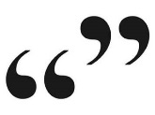
Fashion Publicity
I don’t do fashion. I am fashion.
-Coco Chanel
Brand Name
Slogan
Why customers should wear this item
Name: _________________________________________________________
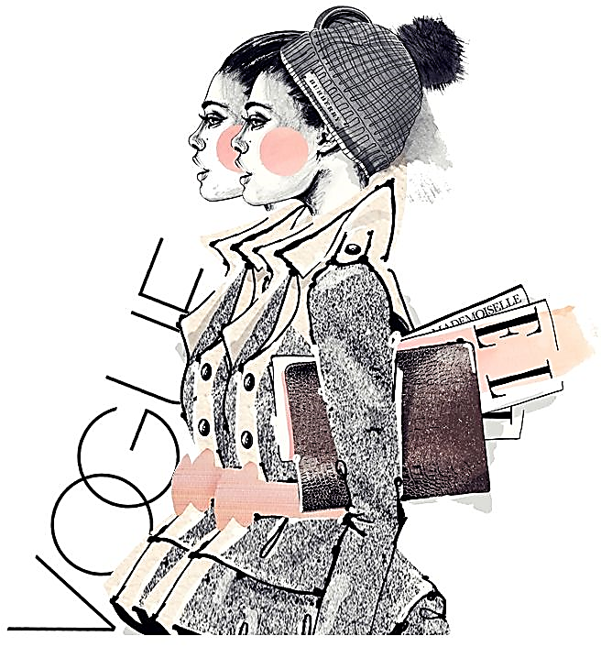
Fill in the following factsheet according to the clothing item you chose.

