THE STORY OF MY LIFE
by Maria Jose Verdugo

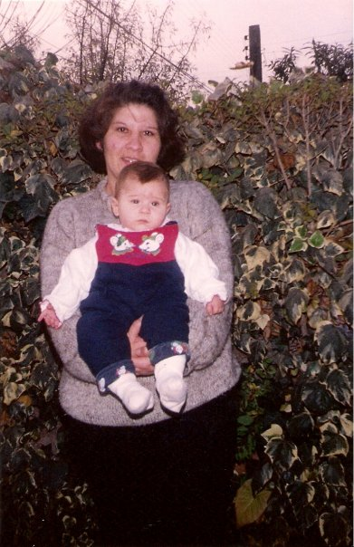
It was a warm night in the beginning of December when a 29-year-old woman felt the first contractions, which meant that after nine months waiting, her little girl was about to be born. In the morning of December 6th on 1995, I was born at Hospital Sotero del Rio in Puente Alto.
In my little family we are just three people: my mom Ines, my dad Jose, who belongs to the Army, and me, Maria Jose Verdugo Vilches. As you can see, I’m an only child, which has turned me into daddy’s girl. I must say that actually we are four, we have a black dog: Coke; my godfather gave it to me nine years ago when he had just been alive for two weeks. As we have grown up together, he has turned into my little brother.
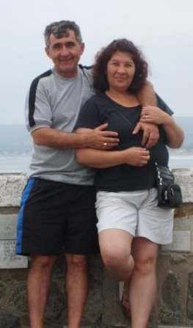
My relationship with my parents is the best one, even though we fight every day –and sometimes for no reason- my mom is my best friend, she is always there for me no matter the hour or how far we might be from each other. My dad is my adventures’ partner, he always goes everywhere I ask him to and he worries for my safety every time we do something “dangerous”.
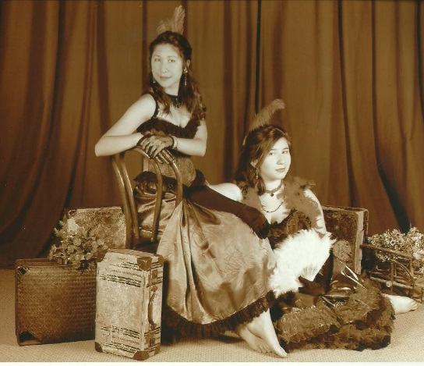
As my mom worked in a playschool and my dad was in the Army, nobody could take care of me while my parents were working, I had to start going to playschool since I was six months. One of my mom’s colleagues used to live in the house next to my granddad’s, so she and my mother grew up together and became really good friends, just like their moms used to be when they were young. Because of that, when my mom’s friend got pregnant two years after I was born, her daughter, Antonia, became my best friend and we are like sisters. The best part of knowing your best friend since you are a “Diva en pañales” -as we call ourselves- is that we know each other like nobody else: we know when we lie, when we are sad or when we need a hug and every day we spend together is amazing and unforgettable.

When I was a child I used to be outgoing and I didn’t have problems talking with people of my age, and that’s why starting school wasn’t a problem. But while I was growing up and as I was surrounded by older people –my entire family is older- I started to become shy with teenagers, I preferred talking with older people than girls or guys of my age. And that was first reason why high school turned a little bit more difficult for me.
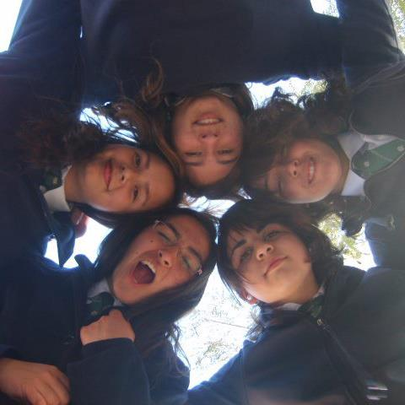
At the age of fourteen I joined to a swimming team in order to learn how to swim. I have always loved nature and especially water, but I didn’t know how to swim properly. I tried to go to the pool every day to practise. Swimming turned into the only moment when I really felt comfortable, I was good and that made me feel I could make a difference among my friends. By the moment I started to compete I got sick and nobody knew what was wrong with me. One night I just “stopped breathing”, as my mom said, and my parents decided to take me to the hospital although I didn’t want to. There, they put me a mask so I could breathe better. After some medical examination, they found out that I was asthmatic and that I couldn’t keep swimming because the vapour clogged my lungs. That completely changed my life. I just couldn’t understand why I had to stop doing what I loved the most, but I had to do it. So I just stopped swimming.
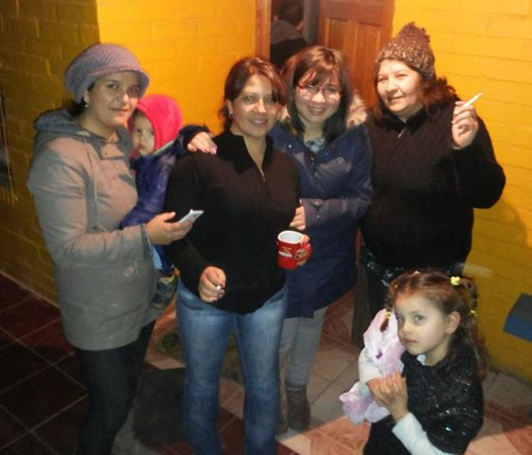
Starting high school was really difficult to me, I had had some problems with a few girls of my class during eighth grade and it brought me a lot of problems later. I had my “Sweet fifteen’s party” and I had an amazing night with my friends, family and classmates. The next year, second of high school, one of the girls I had argued started to bully me. After two years trying to avoid her, I just collapsed. One day, after school, my cousin came home and while we were having lunch I decided to tell my parents. I do not remember their faces but what I do remember is my cousin hugging me so hard that for one minute I felt that it was just a nightmare.
After we talked and I told them everything about what had happened, they gave me the chance of leaving school and starting somewhere else. I thought about it for a few weeks and then I decided not to leave my school because I had too many experiences and memories there and I wasn’t going to forget them. I went to a psychologist because my parents thought I was emotionally unstable. At the beginning I didn’t agree and I was a little bit sceptical, but I must say it actually helped me. Nevertheless, I finally got better because of my friends and family, who were always next to me trying to support me.
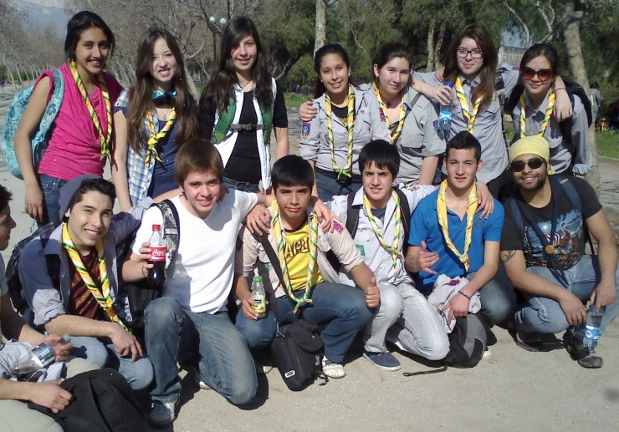
The doctor told me that I should start going to some activities were I could meet new people and forget what I had experienced. A friend of mine was part of a Scout Group and when I mentioned it she made me join the group. I met new people, went to a few camps and knew some places of Chile. They made me learn from the smallest things of life, to appreciate nature and to enjoy a minute watching the stars.
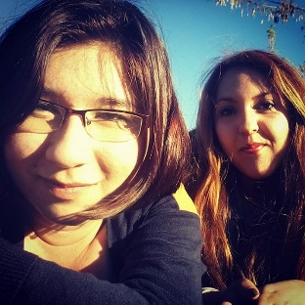
When all the storm passed away, a classmate turned into a really close friend. Her name is Carolina and we keep meeting and talking every day. We love talking about guys, our platonic loves from television and to lie on bed just listening to music. She became really important for me and I really expect us to keep being friends in the future.

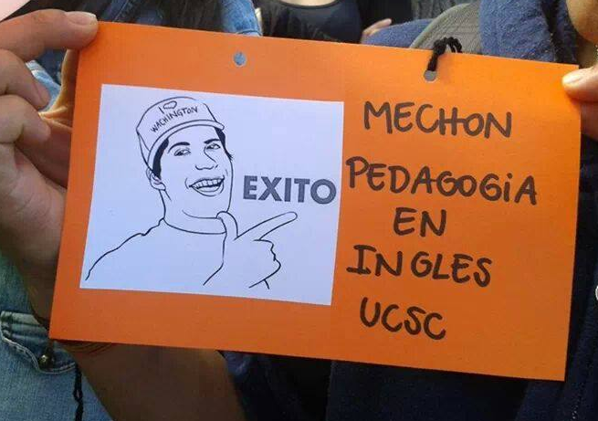
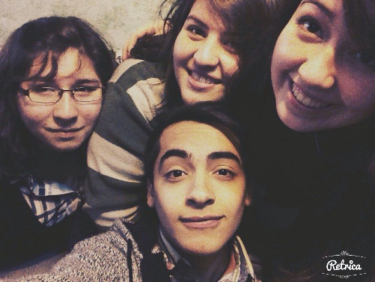
At the age of 17 I went to an English Winter Camp, where I met a lot of people of my age, pedagogy students and volunteers from English speaking countries. Three of these guys turned into one of my closest friends: Marisol, Victoria and Maximiliano. They are really fun and every time we meet I just can’t stop laughing about the nonsenses and jokes they make. The best thing of them is that despite we might have no money for buying food or getting together, being together is all they care about. We also talk every day as a group and this make me feel like if I was at home.
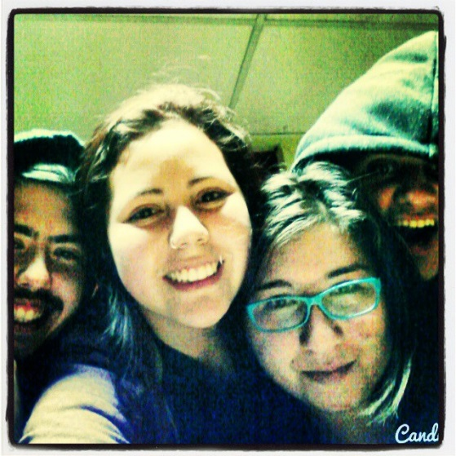
School finished, I had to take the PSU and make one of the most important decisions of my life. I wasn’t sure if I was going to study English Pedagogy or Maths because I was pretty good at both of them, but I chose English because it was what I really liked. I couldn’t get the points enough for getting into the university I wanted so I decided to leave Santiago. I applied to the English Teaching Programme of Universidad Catolica de la Santisima Concepcion and I just left my home. Even though I thought it would be hard, I never regretted the decision I had taken. It was a chance for starting from zero and meeting new people.
These last months I have had the chance to meet amazing people who have become my friends, and to find out that I am independent and that maybe stop swimming was not the end of my life, because when I stopped doing it I focused in learning this second language.
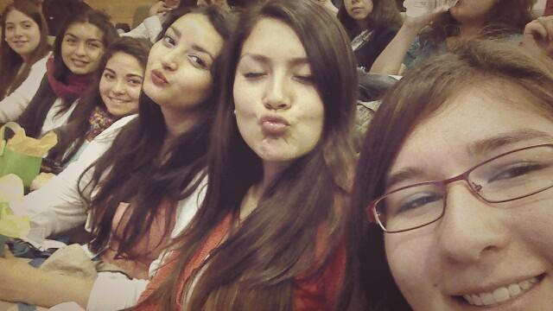
When I found the boarding-house where I live, I was told that eight men were going to live with me and I would be the only girl. I knew it would be weird but I thought it was going to a kind of challenge for me. They were wrong, I live with seven men and a girl, who are also students from the same university. We have a great relationship and I am pretty sure that the next four years in this city are going to be amazing, because changing the city and the people around me was maybe one of the best choices I could have ever done.

